### Assignment 1



Solution:

<https://hub.docker.com/r/448555/kubeassignment> ------ for docker image

<https://hub.docker.com/r/448555/kubeassignment1>

<https://github.com/saaritssinha/kubeassignment1> ------ for yaml files for kubernetes

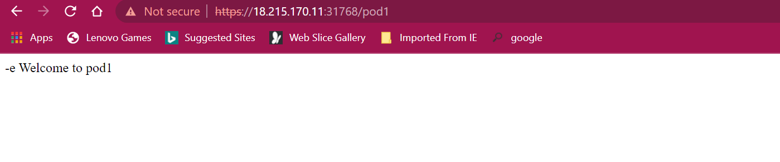

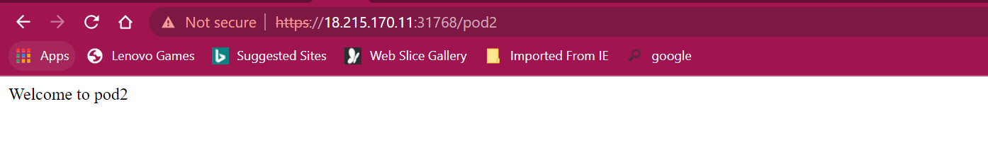

### Assignment 2

**Problem Statement:**

You work for xyz organization. Your organization uses a Kuberenetes for container orchestration. Your company requires you to monitor your clusters.

You have been asked to:

1. Create an external host and create a hshar/webapp deployment on the cluster

2. Deployment must have 4 replicas

3. create a dashbaord using the external host

4. setup promethus and garafana from the external source for the cluster

1. After Kube bare metal or minikube installation.
2. For dashboard creation

kubectl apply -f https://raw.githubusercontent.com/kubernetes/dashboard/v2.4.0/aio/deploy/recommended.yaml

kubectl proxy

Edit the Kubernetes Dashboard service for nodeport configuration.

kubectl create serviceaccount cluster-admin-dashboard-sa

kubectl create clusterrolebinding cluster-admin-dashboard-sa \ --clusterrole=cluster-admin \ --serviceaccount=default:cluster-admin-dashboard-sa

TOKEN=$(kubectl describe secret $(kubectl -n kube-system get secret | awk '/^cluster-admin-dashboard- sa-token-/{print $1}') | awk '$1=="token:"{print $2}')

